1. 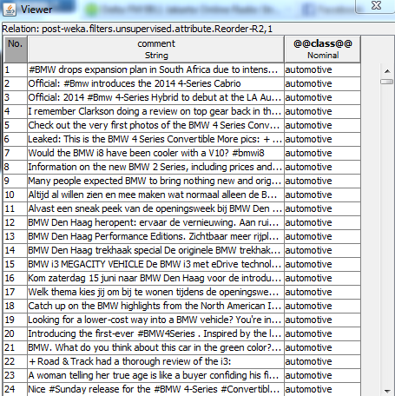**Open training set (googlepost.arff).**
2. **Classify the training set**

**Use meta->Filtered Classifier**

**In Filtered Classifier choose classifier do you want e.g (IBk,Naïve Bayes, SMO, etc).**

**In Filtered Classifier choose multi filter.**

**In multifilter first filter: *StringtoWordVector* (IDF,TFT,outputWordCounts,useStopList) true**

**In multifilter second filter: *AttributeSelection* (InfoGain with ranker threshold 0).**

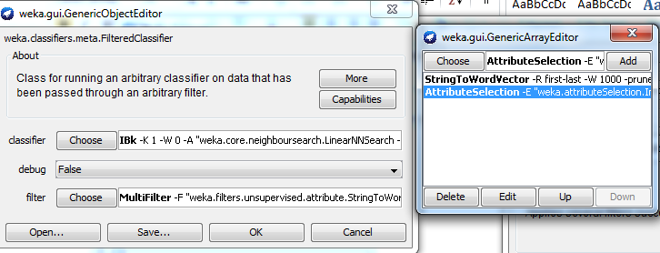

1. **Save Model**